Crib Sheet

Version 3.8

This crib sheet describes how an agent handles the queue, proactively contacts visitor and chats with text and video.

Document ID: Crib sheet 3.8

Date: 2015-05-06

Table of Contents

1 Log In/Log Out 3

1.1 Prerequisites 3

1.2 Start Vergic 3

1.3 Close Vergic 3

2 Prepare desktop 3

3 Visual notifications 3

4 The desktop 4

5 Queue 4

6 Dialogs 5

6.1 Lock 5

6.2 Start a dialog 6

6.3 Case 6

6.4 Shortcuts and auto texts 7

6.5 Video chat 7

6.6 Spellcheck 8

6.7 Notes 8

6.8 Visitor history 8

7 Visual guidance 8

7.1 Co-browsing 8

7.2 Deactivate co-browsing 9

7.3 Highlight form fields 9

7.4 Get page with form values 9

7.5 Get the visitors current site 9

8 Transfer dialogs 10

9 End Dialog 10

10 Pause queue 10

11 Phone2web 11

12 How did the visitor end up in the chat? 12

13 Agent skills and communication style 13

# Log In/Log Out

## Prerequisites

Use Firefox or Chrome as a browser for the application Vergic Engage Platform (VEP), Internet Explorer is not supported.

## Start Vergic

**1.** Start Chrome or Firefox by clicking on one of the icons.

**2.** If you’re not already on the application webpage go to:

*http://companyname.psplugin.com*

**3.** In the field *Username* fill in your email address and in the *Password* field fill in the password. Click on the button *Log in*.

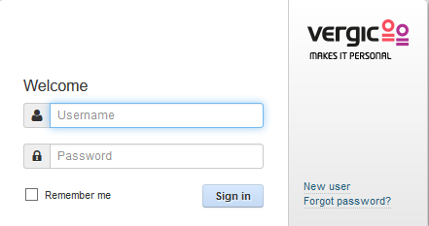

**3.a** If this is the first time you login you need to follow the instructions in the activation mail that has been sent to you.

**4.** After you have logged into the application you will see an empty desktop.

## Close Vergic

**1.** Click on the icon in the upper right corner to log out.

**2.** Close the web browser after you have logged out.

# Prepare desktop

To be able to use visual guidance you must click on the ”Shield” in your Firefox or Chrome browser to be able to allow insecure content. This action must be done every time that you start your browser.

On Firefox it looks like this:

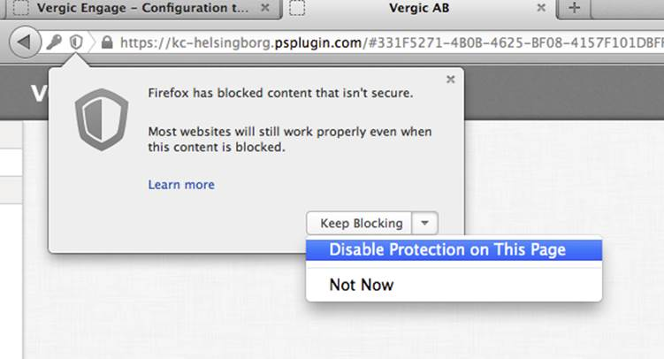

On Chrome it looks like this:

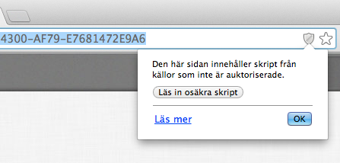

# Visual notifications

It is possible to improve visual notification regarding visitor’s updates in browser Chrome and Firefox, if there is a new visitor in queue or if the visitor has written a chat message.

The notification will appear if the agent is not actively working with Vergic but is logged in.

This functionality can be enabled via an account setting. If the account setting is enabled then the agent can easily allow the notifications by clicking on the *Allow* button in the application and additional allow button in the browser.

Enable the notification by clicking on *Allow*.

Macintosh HD:Users:erikahedblom:Desktop:Skärmavbild 2014-07-22 kl. 15.15.00.png

The agent is then prompted with something similar to this.

Firefox

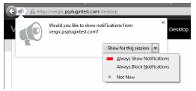

Chrome

Macintosh HD:Users:erikahedblom:Desktop:Skärmavbild 2014-07-22 kl. 15.35.24.png

When the visual notification is enabled and the agent is logged in but not actively using Vergic, a message will be displayed if there is a new chat message for the agent to respond to.

This will enable the agent to be logged into Vergic but at the same time more easily do other work on the same computer. When there is something for the agent to pay attention to he/she will be prompted as seen in the images below.

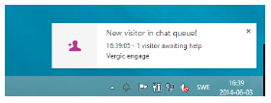

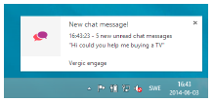

# The desktop

The desktop contains of three parts

1) Left side fold out menu

2) The dialog area

3) Right side fold out menu containing the queues.

To view the fold out menu fully, you need to hover it with your mouse pointer.

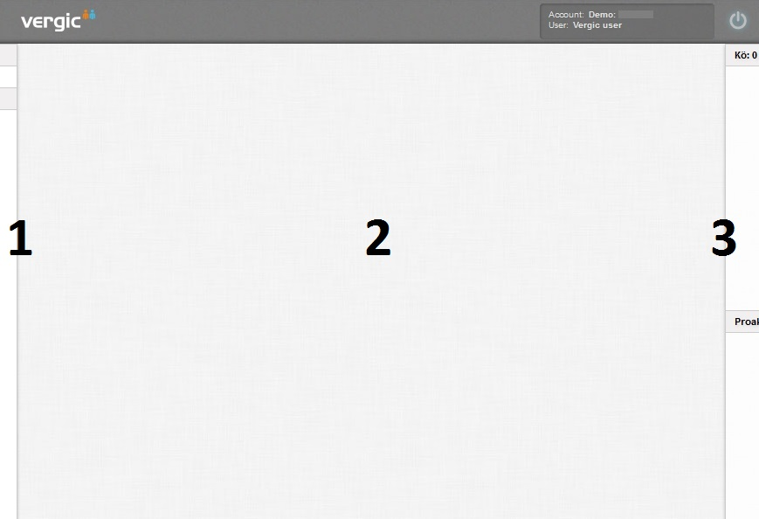

The dialog area is empty until a dialog starts. When a dialog is started the dialog area is divided into two parts:

1) A maximized dialog subarea

2) A minimized dialog subarea for other active dialogs. If the agent only has one active dialog this area will be empty.

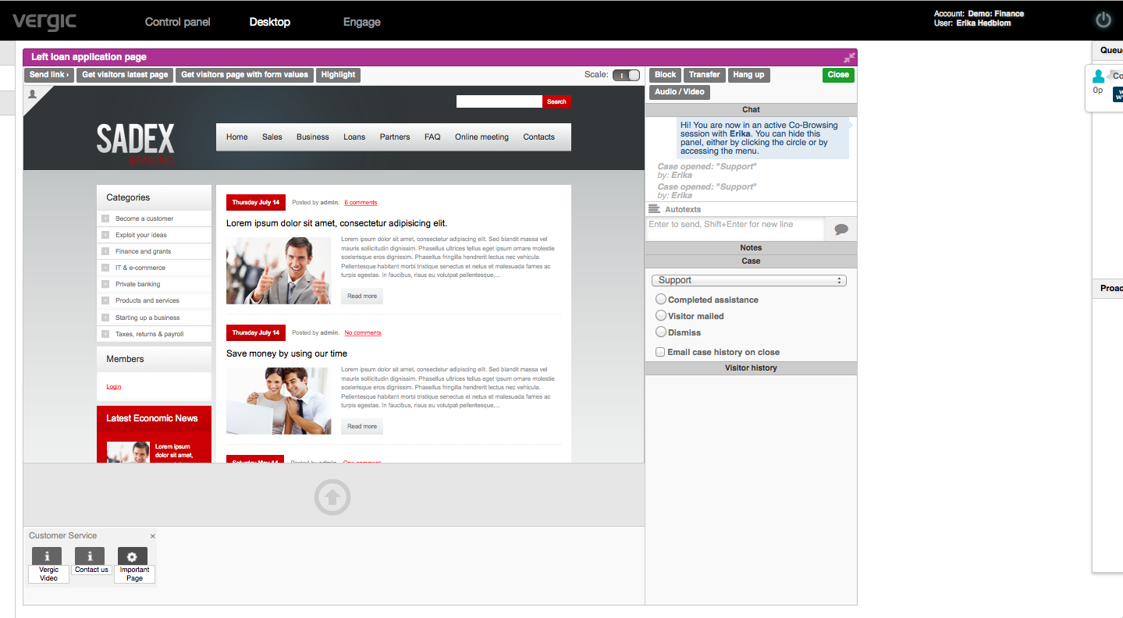

# Queue

The queue is a fold out menu, per default it is minimized on the desktop. You need to hover it with the mouse pointer to make it expand.

There are two queues

On top is a reactive queue. The reactive queue shows the visitors who have actively asked for help from contact banners. Below the reactive queue you find the proactive queue. Visitors in the proactive queue have not actively asked for help from a contact banner but their behaviour on the website show that they might be in the need for help or show an interesting behaviour.

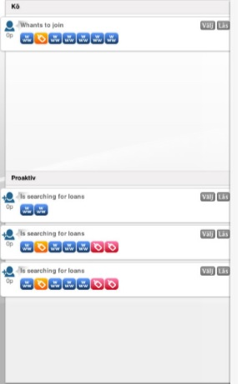

On each queue item in the queue, the agent see a header which indicates from where the visitor asked for help on the website and/or why the visitor might be in need of help. There is a set of icons showing the browsing history of the visitor. The icon to the far right indicates where the visitor is located right now. By hovering with your mouse over the icons from right-to-left the agent can follow the visitors browsing history.

The reactive queue is sorted by the time the visitor has spent in the queue. The longer time in the queue the higher up.

The proactive queue is sorted based on a proactive score, from high to low. What score the visitor has, is based on a set of proactive rules which scores the visitors behaviour on the website.

# Dialogs

## Lock

You can pick a visitor in the queue and ”lock” him/her to you. Click on the *Lock* button to do this.

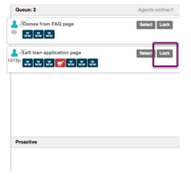

The chat will not start until you click *Start*. Then the visitor will get a message that you are ready to chat.

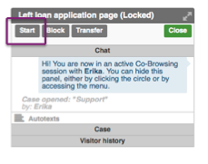

This is a way to keep a good flow of visitors to your agent. It can also be used to pick a certain visitor that you know you must help.

## Start a dialog

Click on *Select* in the queue to initiate a dialog.

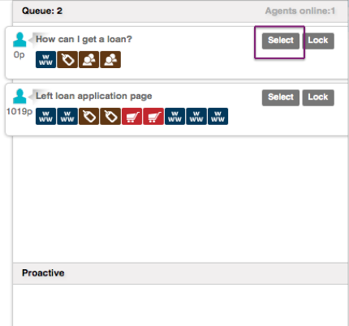

Once selected a confirmation dialog will appear for the visitor, in which he/she need to answer yes or no. During the confirmation time, the dialog will be placed on the agent’s desktop in pending state.

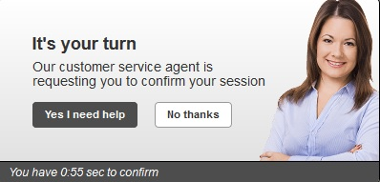

If the visitor answers no: the dialog will not start. The pending dialog window will show the text: Visitor declined.

If the visitor answers yes: the dialog will start and a greeting message will automatically be sent.

You can handle multiple dialogs at the same time, but you can only see the visual guidance window for one visitor at the time. The other active dialogs will be placed to the right of the maximized dialog window. You can chat in all the dialog windows without maximizing them.

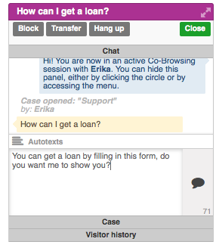

When a visitor has sent the agent a message the agent will be notified with a sound and the dialog starts blinking.

Three dots blinking are shown in the chat window when the visitor is writing.

## Case

All dialogs starts with a pre-defined case. A case can be seen as an information package, containing a set of auto texts, shortcuts and reasons/close options. The case that is pre-chosen at start-up is based on where on the website the visitor asked for help. You can always switch case during the dialog by clicking in the combo box below the chat window.

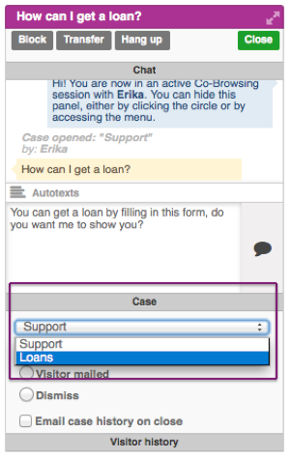

Shortcuts and auto texts will automatically adapt to the chosen case.

## Shortcuts and canned responses

Shortcuts and canned responses/auto texts are used to create a more effective dialog. Click on the button *Auto texts* in the dialog window and you will see a list of available auto texts for the chosen case type. Click on an item in the list to use it. The auto text will be pasted into the chat window. You can edit the auto texts before sending them to the visitor.

Auto texts are visible both in maximized and minimized chat window.

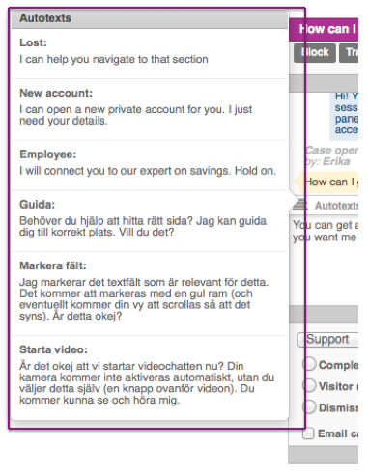

There are different types of shortcuts with different purposes. The shortcuts available are: URLs, PDFs, Videos, Images, and other. Shortcuts are used to guide the visitor to a certain web page or share content.

To use a shortcut, drag and drop it into the drop zone. The drop zone is located just below the visual guidance window.

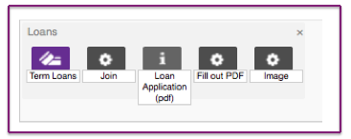

The shortcuts are only visible when the dialog window is maximized.

## Video chat

All dialogs starts in chat mode, but you can at any time switch to video by clicking on the button *Audio/Video.*

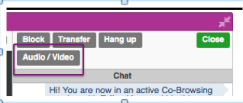

The dialog must be in maximized mode to be able to use video. You can only have one video chat with one person at the time. It is only the agent who can start a video chat; the visitor can start the video chat after this.

When you have clicked on the Audio/video button you will get a question from the Adobe Flash player, where you allow access to your camera. The button for turning off either the video or the microphone is seen below.

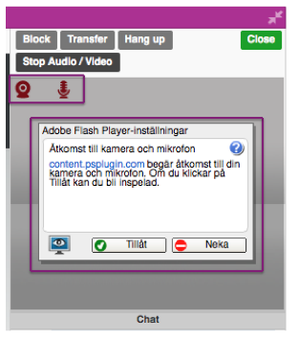

## Spellcheck

For spellcheck to be activated when you chat make sure that the spellchecking function is activated in your browser (see Firefox or Chrome help section).

## Notes

You can take notes during active dialog. Notes are not visible for the visitor. To take notes click on the notes section in the dialog window, which is located just below the chat section. Notes are not visible for the visitor that you are chatting with.

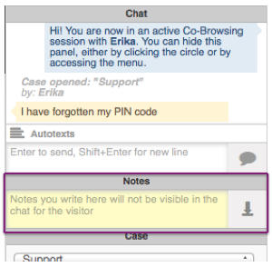

## Visitor history

Dialog visitor history is available for returning visitors, if the visitor has not cleared its browser cache since its last visit. The history section is located below the chat box and will automatically be populated with dialog history items if there are any available. Click on the items to see historical dialog information for this visitor.

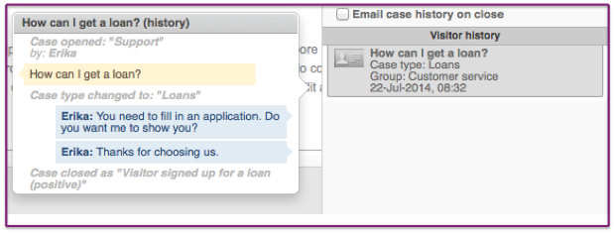

# Visual guidance

## Co-browsing

To start visual guidance the agent need to maximize the dialog window. This is done by clicking on the double arrow icon in the upper right corner of the dialog window.

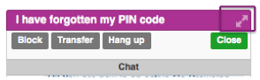

In maximized dialog the agent can see a reflection of the website that the visitor is currently at. The agent can directly navigate the visitor by clicking in the window for visual guidance. When clicking in the visual guidance window the visitor will be automatically navigated.

Every time the visitor navigates during the dialog the agent’s visual guidance window will automatically update to reflect current visitor webpage.

## Deactivate co-browsing

It is possible to deactivate the visual guidance function so the visitor is not navigated when the agent clicks inside of the visual guidance window. To do this click on the button *Deactivate co-browsing*

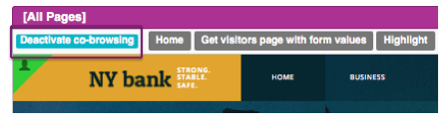

You can now navigate to the right place without disturbing the visitor with a lot of page loads.

When the agent has found the correct page the agent can click on *Send link>.* The visitor will be moved to this page and also get the link to the dialog.

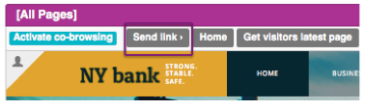

The agent can also choose to click on the button *Activate co-browsing*, and the visitor will be moved to the correct page.

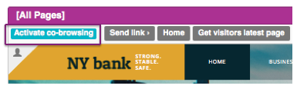

## Highlight form fields

To make it easier for the visitor to know which form fields he/she should pay attention to, the agent can highlight form fields.

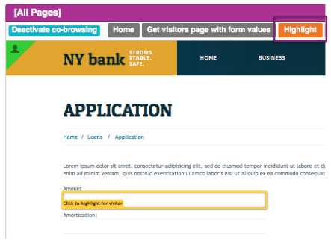

To highlight a form field click on the button *Highlight*. Then click on the form filed that should be highlighted in the visual guidance window.

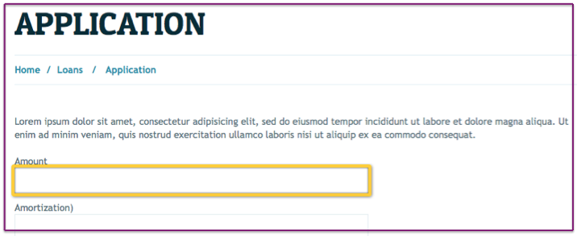

The field that was highlighted will get a yellow border in the visitor’s browser.

## Get page with form values

By clicking on the button *Get visitors page with form values* you will retrieve information that the visitor has filled in on the form. You need to actively click on the button to continuously retrieve form values; there is no auto update.

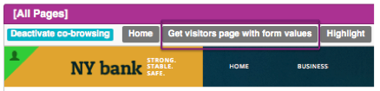

## Get the visitors current site

If you have deactivated co-browsing and the visitor have continued to navigate on the webpage, then you might need to know where the visitor is before you move him/her. Click on *Get visitor latest page.*

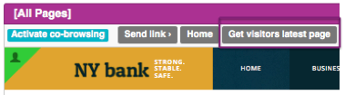

You will then see the visitor’s current page, ask if you can move the visitor, find the page and then click on *Send link*.

# Transfer dialogs

If you have multiple competence groups configured it is possible to transfer dialogs between competence groups. Click on *Transfer* and choose the new competence group from the drop down.

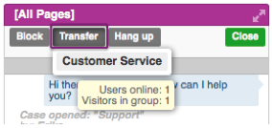

The visitor will moved back to the queue but in a new competence groups queue and a new agent with the right competence can pick him up.

Before you choose to do transfer it can be an idea to write a note in the dialog that describes why you transfer this visitor.

# End Dialog

Click on the button *Hang up* to end the dialog with the visitor. Once the *Hang up* button is clicked the dialog will end at the visitor side and dialog history will be shown. (1)

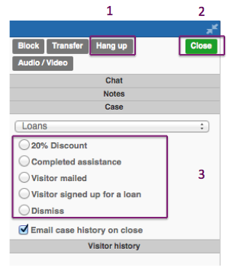

Hang up will not close the dialog window, before you can close the dialog window you need to choose a close option. Click in one of the radio buttons available to choose a close option. (3)

Once the close option is chosen click on the button *Close* to completely close the dialog window. (2)

# Pause queue

An agent can temporarily pause her/his queue.

When an agent chooses to take a pause then the agent must first finish the on-going dialogs or make a *Transfer* back to the queue so another agent can continue these dialogs.

All agents should not take a pause at the same time. There needs to be someone who supervises the queue.

To make a pause the agent change his/her status to Away in the upper right corner of the screen.

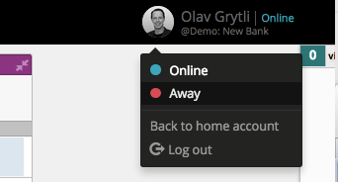

Paus/away status

Macintosh HD:Users:olavgrytli:Desktop:Skärmavbild 2015-05-06 kl. 15.53.48.png

To start working the queue again the agent needs to change the status to Online.

Macintosh HD:Users:olavgrytli:Desktop:Skärmavbild 2015-05-06 kl. 16.04.42.png

This functionality also enables the possibility for a sole agent that needs to logout outside the openings hours. The agent can choose to do pause/away. That means that no more visitors can get into the queue. The agent can finish working with the queue she/he has- When the queue is empty the agent can click on log out.

By doing this, the agent does not have to “throw” any visitors out from the queue.

Worth to know is that if Pause/away is used by a single agent who is the only one logged in, then the banners will be visible to visitors until they do a reload of the page. If such a visitor stands in a queue, they will get the following message.

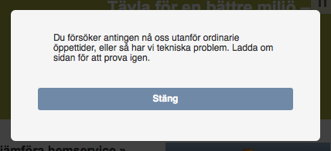

The visitor will click on close, reload the page and then the possibility to get into queue is not visible.

# Phone2web

Phone2web is an additional service to Vergic Engage which makes it possible to utilize all the features of Vergic during regular phone calls. The agent generates a one-time code in Vergic that will link customer service and the customer together. This code can be conveyed from the agent to the visitor via email or phone call. When the visitor received the code, he/she may enter this code on the website and get into direct contact with the agent who sent the code. If this happens during a phone it can then be supported by, for example, visual guidance, filling out forms, etc.

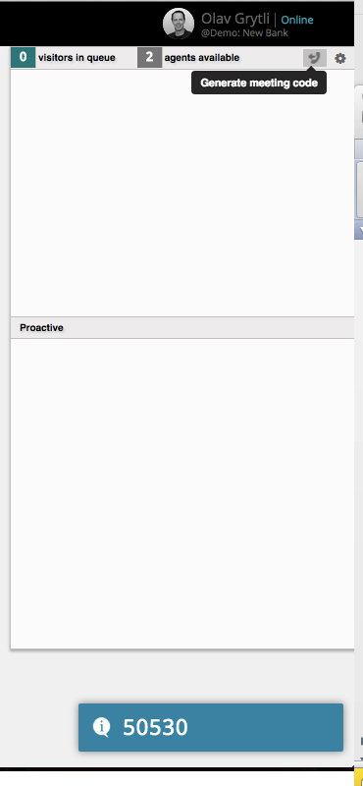

To generate a code the agent clicks in the fold out menu to the right on the Phone2Web symbol. The 5-digit code is rendered in the bottom right corner of the screen. The code is valid for 2 minutes.

# How did the visitor end up in the chat?

In this chapter we’ll describe Vergic Engage from the visitor’s perspective and how the visitor is offered assistance and the underlying mechanisms.

## Behavior and profiling

Vergic Engage uses a patented algorithm that identifies visitors that seem to be in need of assistance. This is done in real time and each visitor’s behavior on the website is monitored. The filtering is dynamic and based on a parametric scoring system where different scores lead to that the visitor being offered assistance, displaying interaction points such as contact banners or buttons that automatically appear on the web page.

Vergic Engage also offers the possibility of automatic real time segmentation of visitors based on whether the visitor shows interest e.g. in a specific product or service. It also offers the possibility of automatically assigning visitors to different competence groups working with Vergic Engage so that the visitor receives the most relevant assistance.

Filtering and segmentation is used in order to determine which visitors should proactively be contacted. Visitors can also receive assistance on their own initiative, which is called reactive. The visitor will then be offered this through different dynamic interaction points. The interaction points are strategically placed where the visitor normally needs assistance and are customized to the situation in terms of size, exposure, and placement and with a message that matches the situation. The exposure also takes account of the current workload on customer service.

## Contact banners

All visible parts of the contact banners and chat panels can be adapted to the graphic profile, design, and look and feel of the website. The contact banners can be divided into different types.

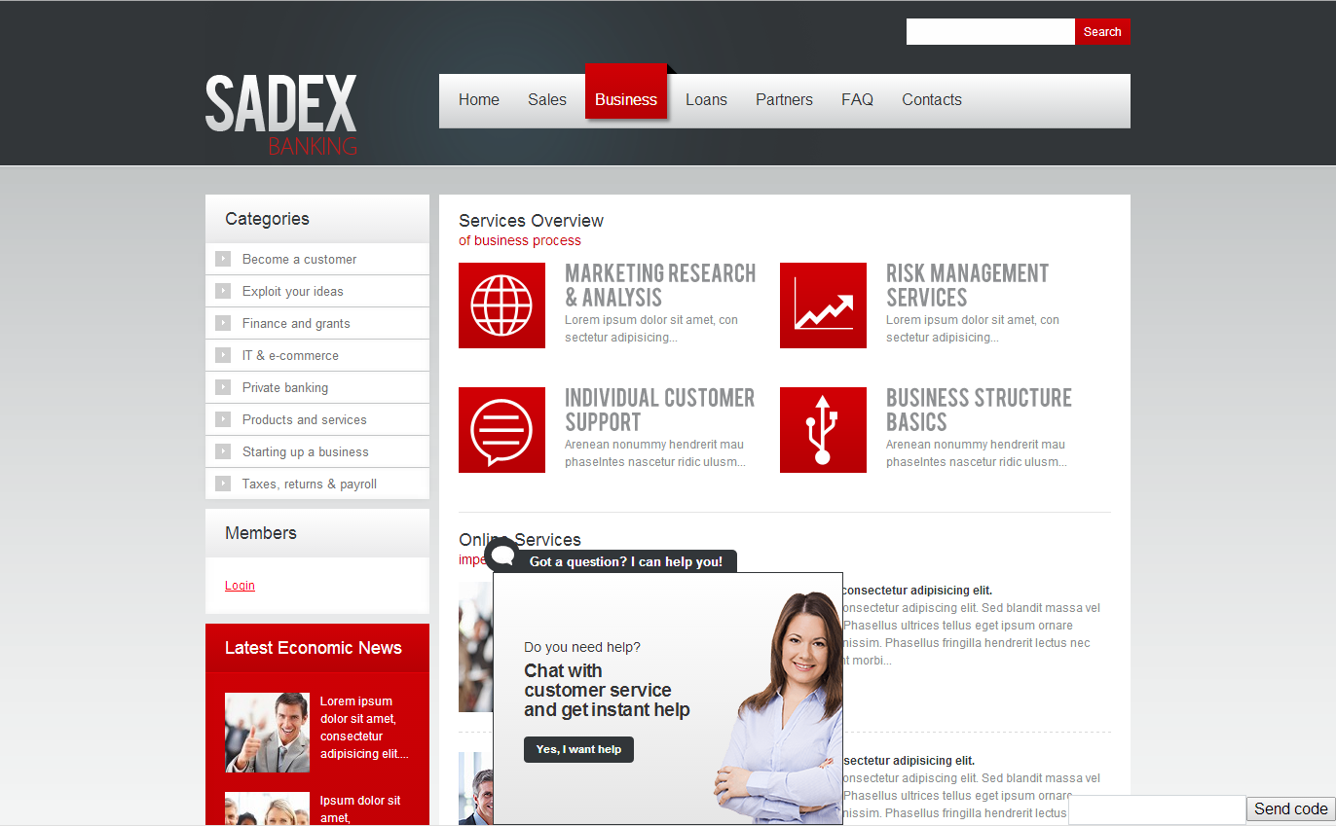

# Agent skills and communication style

Vergic Engage is a platform that offers all the necessary functions and options needed to service the visitors on the website with personal online chat. Regardless of this it’s the agent’s competence and communication style that is critical in order to succeed in the dialog with the visitor. This translates into some key practices, the tone of voice and the ability to adapt to the trust and lust of the visitor. In this chapter we’ll highlight some do’s and don’ts in order to achieve best-in-class online customer service.

Worth noting

67% of shoppers with a previous chat experience continue to actively seek chat options on merchant websites.[1]

77% of chat users agree the new interaction method positively influences their attitude toward the retailer they were considering buying from. [2]

63% of respondents reported they were more likely to return to a website after experiencing live chat.[3]

38% stated they purchased from the e-commerce website as a direct result of the chat session itself.[4]

## Best practice – Best-in-class customer satisfaction

Research show that there are some practices that are more important than others in order to achieve best-in-class customer satisfaction. These are:

Average Response Time (ART)

Average response time refers to the time between customer questions and agent

responses. The customer expectation is real-time response. For the ideal chat session, responses were provided within 30 seconds.

Expectation setting

Expectation setting focused on whether or not the agent gave an estimated wait time for delayed responses.

Accuracy of response

Response accuracy is paramount to ensure customer satisfaction and maintain the overall integrity of the brand. For benchmarking purposes, chat transcripts were analyzed for inaccurate, conflicting or confusing information.

Direct objective responses

Best-in-class chat responses directly answered customer questions, included only one or two ideas per response, and avoided promotional copy.

Conversation flow

Customers expect a personalized, brand-appropriate experience, even when using online chat. Ideal online chat conversations needed to flow with the appropriate use of pre-defined versus free form responses.

Patience

Questions should be resolved accurately while agents drive to closure. Agents should not rush a chat session to hit efficiency metrics.

## Tone of voice

Another important factor that is directly linked to the outcome of the dialog is what can be termed the tone of voice. Research shows that the factors below have a major impact.

Conciseness and sticking to the point

Limit number of words per sentence to reduce confusion, and directly respond to prior customer question.

Grammar, spelling and sentence structure

Use most grammatical rules, including capitalization and punctuation. Spell accurately to support credibility of agent. Put critical content at the beginning of responses. Put formal responses in complete sentences, while less formal responses can be sentence fragments.

Voice and tone

Conform to the personality of the site (e.g. informative, professional and innovative). Tone should express the mood or feeling of the voice (e.g. friendly, upbeat and conversational).

Terminology

Use language that has mass appeal. Avoid slang, clichés and other references that are specific to a region. Can be used if customer starts using it!

Personalization

Use customer name and other customer information if available.

Grammar rules for chat

1. Use periods at the end of complete sentences, and question marks after direct questions.
2. Watch the built-in spell-checker and fix spelling mistakes.
3. Capitalize the first word of a sentence, proper nouns, and the first word of a salutation/closing.
4. Use a comma plus a simple conjunction (and, but, for, nor, yet, or, so) to connect two independent clauses.
5. Use active voice.
6. Use acronyms (e.g. btw, fyi, asap but also tnx, b4, lol or smileys) with care and make sure you know and follow the company policy.

## Trust and lust – things to consider

Understanding the visitor and what mood he/she is in and what he/she feels right now and adapting the dialog to this is key in order to achieve a great customer experience. Consider the questions below and how they affect the customer but also you as agent and how you need to relate to them in order to achieve a successful chat.

1. What mood is the customer in?
2. Is he/she frustrated? - Provide clear and straight answers, facts and solve the problem.
3. Why is the customer visiting your website? Inspiration, gathering facts, wanting to buy something, something else?
4. What is your experience with other channels and how can you transfer that knowledge into the chat?

Consider the following scenarios and think about how you would act handling these visitors in a chat:

1. Confused visitor needing guidance and help to find information on the website.
2. Visitor needing help in getting support.
3. Help a visitor who leaves an ongoing process, e.g. checkout in e-commerce.
4. Ensure that the customer understands what he or she has ordered.

1. Bold Software Survey (2010)
2. Bold Software Survey (2010)
3. e.Marketer.com Survey (2009)
4. e.Marketer.com Survey (2009)